PROJECT – 2

Elkhan Ismayilzada

For 1D sampling rate conversion for x2 conversion, find the interpolation filters for sample-and-hold, linear interpolation, and cubic convolution interpolation (a=-0.5). Plot the impulse and magnitude responses of the filters.Chart, box and whisker chart

For 1D sampling rate conversion for x3 conversion, find the interpolation filters for sample-and-hold, linear interpolation, and cubic convolution interpolation (a=-0.5). Plot the impulse and magnitude responses of the filters.

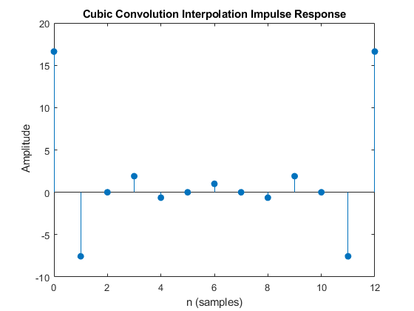

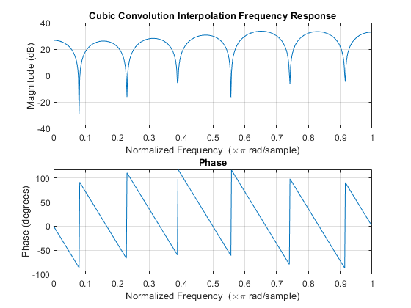

Using double for-loops, implement the filter by h=ones(5,5); (the center is the (0,0)th sample) with zero, repeated, and periodic boundary conditions. Show the original, filtered, and difference images. (The size of the filtered image is the same as the original.)

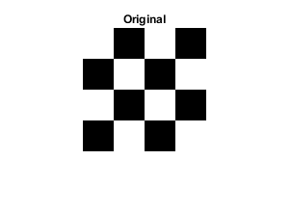

Scale the image by 3/2 by i) upsample the image by 3, ii) interpolate with a third band filter iii) anti-alias with a half band filter, iv) and downsample by 2. Display the result.

Scale the result by 2/3 by i) upsample the image by 2, ii) interpolate with a half band filter, iii) anti-alias with a third band filter, iv) and downsample by 3. Display the result.

For sample-and-hold interpolation MSE is 0.004212.

For linear interpolation MSE is 0.003165.

For cubic interpolation MSE is 0.003376.

Compare the demosaicing performance. We can check the absolute error between the demosaiced and original images, check if there are any demosaicing artifacts, and also measure the mean square error (MSE) between the demosaiced and original images.

MSE for cubic interpolation (step 2) is 0.000570 and for interpolated (step 3) is 0.000570.

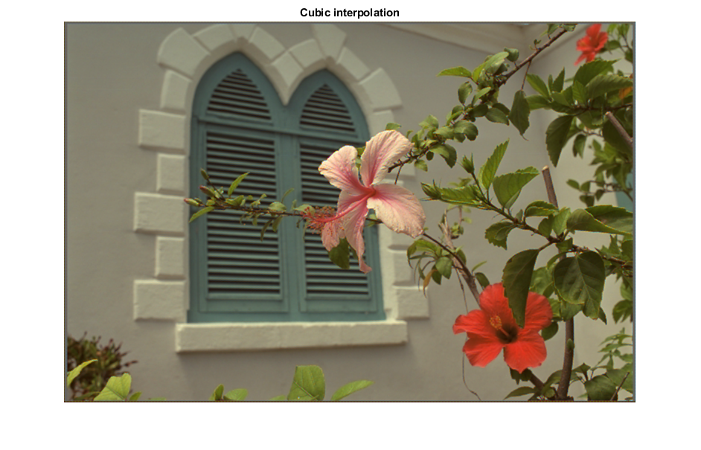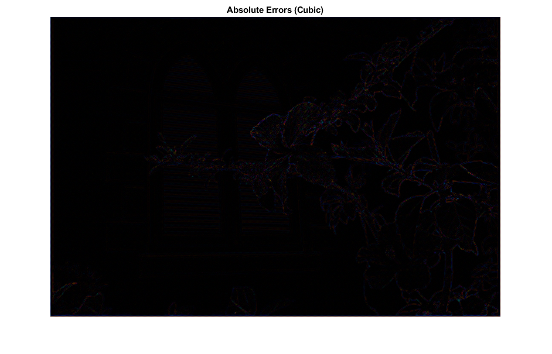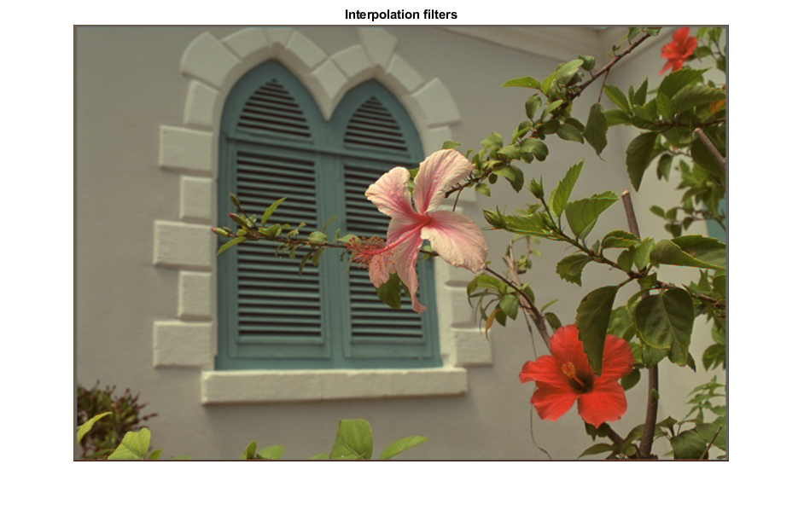

Show the original, compressed, and (absolute) error images. Measure the MSE between the original and compressed images.

MSE score is 2.6260e-04.

Collect the quantization results (indices, not quantized coefficients) of each block into a matrix b. Save it into a file by imwrite(abs(b),'comp_qf.tiff'). Measure MSE between the compressed and original images. Plot MSE vs file size.

Download signal.mat, and show x. Apply 128 tap 2D fft to non-overlapping 128 ⇥ 128 sample blocks and plot the magnitude responses (absolute values of the 2D fft) using mesh.

